The Wessex Road Club on behalf of South DC present:
Wessex Road Club Hilly 24 mile Time Trial - Sunday 14th April 2024

Promoted under Cycling Time Trials rules and regulations.
Headquarters
Holt Village Hall, Harts Lane, nr Wimborne. Dorset. BH21 7DJ. Open from 7.30 am for registration.
Printed copies of the start sheet will be available for collection, along with race numbers. There are toilet facilities and tea, coffee and cakes will be available.
Event Secretary
Harry Lodge
Cynwyd, Wyndham Lane, Allington, Salisbury, SP4 0BY
07880367579
halosports@hotmail.co.uk

Time Keepers, Marshals and Volunteers
Start Time Keepers: Bob Richardson
Finish Time Keeper: Ros Spencer
Recorder: Marcia Rendell
Signing On & Off: Willie Kirkland and Anne Kirkland
Marshals: Members and friends of the Wessex Road Club
A full list of everyone who helped out will be with the results sheet. Without all of these fantastic volunteers we would have no race.
Prizes for Each Category
1st 2nd 3rd
Men (TT Bike) £20 £15 £10
Women (TT Bike) £20 £15 £10
Veteran (TT Bike) Scratch £15 £10
Youth (TT Bike) £15
Fastest Team of 3 (TT Bike) £10/Rider

Men (Road Bike) £20 £15 £10
Women (Road Bike) £20 £15 £10
Veteran (Road Bike) Scratch £15 £10
Junior (Road Bike) £15
Fastest Team of 3 (Road Bike) £10/Rider

Instructions to riders
- Observers may be in attendance along the course;
- Riders must not make U-turns in the vicinity of the Start and Finish;
- The HQ is in a village, although away from houses, please give consideration to local residents in early morning
- NO warming up on the course;
- Your attention is drawn to the following CTT regulations:
  - Regulation 14(j) - Front light & Regulation 14(j) - Rear light. No competitor will be allowed to start without a working front and rear light, either flashing or constant, fitted to their machine in a position clearly visible to following road users and active whilst the machine is in use;
  - Regulation 15 - Helmet. All competitors MUST wear a hard/soft shell helmet that meets internationally accepted safety standards;
  - Regulation 20 - observance of the law;
  - Regulation 21 - paced and company riding.
Prize Presentation
If you can, please stay for the prize presentation, which takes place as soon after the finish as possible.
Parking

There is some parking at the village hall. Alternative parking is at the Old Inn. Car Park 50 yards away, although please vacate this before midday if possible.
From the HQ, turn right then immediately left, and follow “to the start” signs through Furzehill towards Wimborne. (Approx 2 miles). Proceed past the start and turn at safe space approximately 100 yards further. PLEASE DO NOT TURN IN THE ROAD AT THE START AREA. There is NO parking at start or finish. There will be signage from the HQ to the start
Course details
P427: START at milestone "Wimborne 1m" on B3078. (GR SU 011015). Proceed north to the Horton Inn (4.8m) where turn left on minor road to junction with A354 (CARE at narrow bridge oncoming traffic stay left). Turn left (GREAT CARE) onto A354 to Blandford bypass RBT (14.71m) where left / 1st exit to next RBT (15.59m). Left / 1st exit on B3082 to outskirts of Wimborne to FINISH approx. 200 yards short of Queen Elizabeth school.
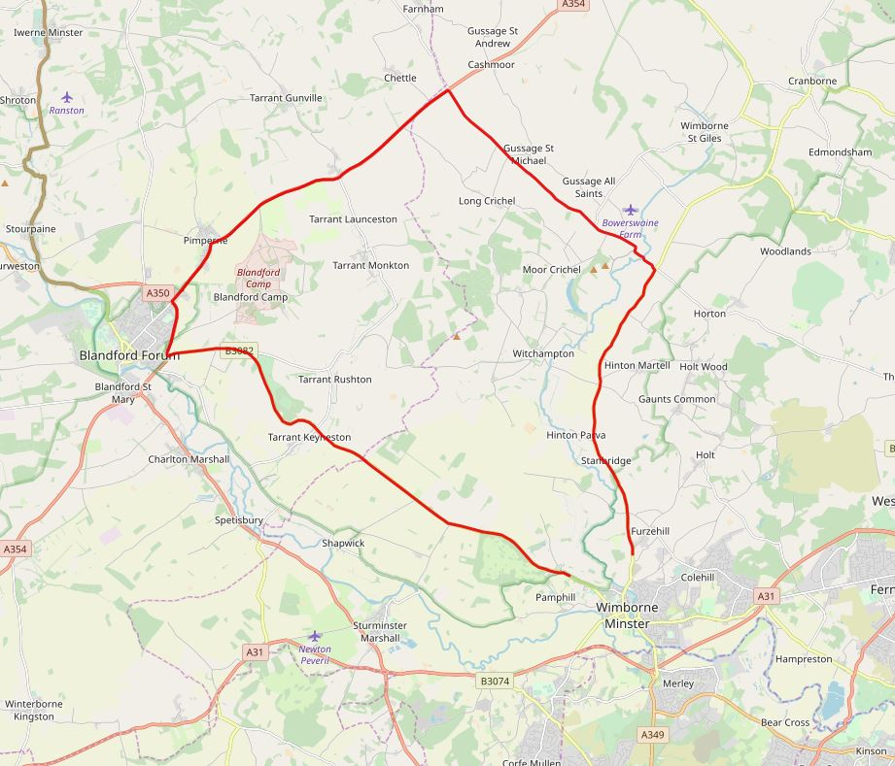

Safe route to start (Allow approx. 10 minutes)
From the HQ, turn right then immediately left, and follow “to the start” signs through Furzehill towards Wimborne. (Approx 2 miles). Proceed past the start and turn at safe space approximately 100 yards further, then return to the start, at the entrance of the layby / beside milestone. PLEASE DO NOT TURN IN THE ROAD AT THE START AREA. There is NO parking at start or finish.
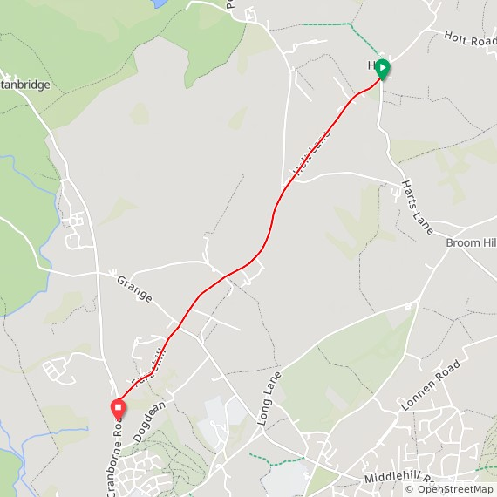

Safe route to HQ from finish
After the finish, continue straight on through traffic lights then fork left at the next traffic lights fork. Turn left at traffic lights at bottom of descent. Follow road back to the start and then follow signs back to the HQ. Total distance is approximately 3.5 miles. There will be signage from the finish back to the HQ.
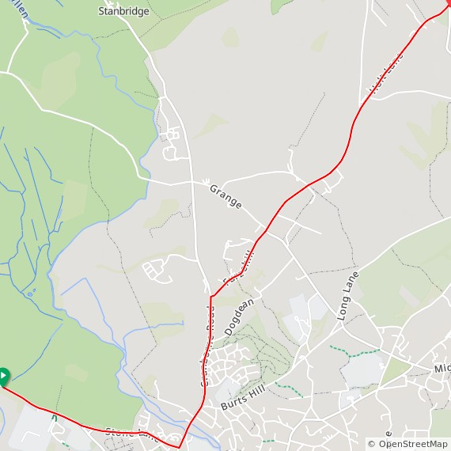

No. | Start | Name | Club | Gender | Category | Time
 |  | Road Bikes
1 | 09:01:00 | Olly Edwards | Wessex Road Club (TT Bike) | M | Senior
2 | 09:02:00 | Robert Wildsmith | Poole Wheelers CC | M | Senior
3 | 09:03:00 | Michael Boardman | Andover Wheelers CC | M | Vet
4 | 09:04:00 | Andrew Mayfield | Bournemouth Arrow CC | M | Vet
5 | 09:05:00 | Alex Rowling | Poole Wheelers CC | M | Senior
6 | 09-06-00 | Max Webber | Andover Wheelers CC | M | Senior
7 | 09:07:00 | George Terry | Poole Wheelers CC | M | Youth
8 | 09:08:00 | Rachel Waite | Andover Wheelers CC | W | Vet
9 | 09:09:00 | Martin Balk | 3C Cycle Club | M | Vet
10 | 09:10:00 | Tim Flynn | Poole Wheelers CC | M | Senior
11 | 09:11:00 | John Hyde | Velo Club St Raphael | M | Vet
12 | 09:12:00 | Louisa Cooper | PDQ Cycle Coaching | W | Vet
13 | 09:13:00 | William Simmons | Christchurch Bicycle Club | M | Vet
14 | 09:14:00 | Adam Daly | Andover Wheelers CC | M | Senior
15 | 09:15:00 | Larry Wiltshire | Chichester City Riders | M | Vet
16 | 09:16:00 | Dave Dent | GS Stella | M | Vet
17 | 09:17:00 | Sien Van Der Plank | New Forest CC | W | Senior
18 | 09:18:00 | Neil Adlem | Andover Wheelers CC | M | Vet
19 | 09:19:00 | Ben Ansell | Poole Wheelers CC | M | Vet
20 | 09:20:00 | Neil Mackley | …a3crg | M | Vet
21 | 09:21:00 | Stuart Thompson | Velo Club St Raphael | M | Vet
22 | 09:22:00 | Phil Harvey | Poole Wheelers CC | M | Vet
23 | 09:23:00 | Stephen Skinner | Velo Club St Raphael | M | Vet
24 | 09:24:00 | Brett Wheeler | Poole Wheelers CC | M | Senior
25 | 09:25:00 | Matthew Buckley | Velo Club St Raphael | M | Senior
26 | 09:26:00 | Edward Hunt | Gillingham & District Wheelers/ Wheels Cycles | M | Vet
27 | 09-27-00 | Dan Newman | Poole Wheelers CC | M | Senior
28 | 09:28:00 | Luke Walton | Elevate RT | M | Senior
29 | 09:29:00 | Howard Bayley | …a3crg | M | Vet
 |  | TT Bikes
30 | 09:30:00 | Sian McPherson | Poole Wheelers Cycling Club | W | Senior
31 | 09:31:00 | Martin Beale | Velo Club St Raphael | M | Vet
32 | 09:32:00 | Laura Daly | FTP (Fulfil The Potential) Race Team | W | Senior
33 | 09:33:00 | Gordon Scott | CC Weymouth | M | Vet
34 | 09:34:00 | Sarah Inwood | Poole Wheelers CC (Road Bike) | W | Senior
35 | 09:35:00 | Simon Berogna | Velo Club St Raphael | M | Vet
36 | 09:36:00 | Naomi Shinkins | Bournemouth Jubilee Wheelers | W | Vet
37 | 09:37:00 | Rufus King | Poole Wheelers Cycling Club | M | Junior
38 | 09:38:00 | Rupert Silman | Bournemouth Jubilee Wheelers | M | Vet
No. | Start | Name | Club | Gender | Category | Time
39 | 09:39:00 | Terry Belbin | Poole Wheelers Cycling Club | M | Vet
40 | 09:40:00 | Tom Clements | Poole Wheelers Cycling Club | M | Vet
41 | 09:41:00 | Vincent Hounsome | Gillingham & District Wheelers/Wheels Cycles | M | Vet
42 | 09:42:00 | Kirsty Mcseveney | …a3crg | W | Vet
43 | 09:43:00 | Michael Naulls | VC Venta | M | Vet
44 | 09:44:00 | James Rowat | Poole Wheelers Cycling Club | M | Vet
45 | 09:45:00 | Andrew Rivett | Velo Club St Raphael | M | Vet
46 | 09:46:00 | Kelvin Hatch | Gillingham & District Wheelers/Wheels Cycles | M | Senior
47 | 09:47:00 | Stuart Peckham | Velo Club St Raphael | M | Vet
48 | 09:48:00 | Gary Francis | Wincanton Wheelers | M | Vet
49 | 09:49:00 | Samuel Wadsley | Poole Wheelers Cycling Club | M | Senior
50 | 09.50.00 | Mike Anderson | CC Moncontour | M | Vet

